Problem: *Drawing Book*

Brie’s Drawing teacher asks her class to open their -page book to page number . Brie can either start turning pages from the front of the book (i.e., page number ) or from the back of the book (i.e., page number ), and she always turns pages one-by-one (as opposed to skipping through multiple pages at once). When she opens the book, page  is always on the right side:

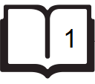

Each page in the book has two sides, front and back, except for the last page which may only have a front side depending on the total number of pages of the book (see the *Explanation* sections below for additional diagrams).

Given  and , find and print the minimum number of pages Brie must turn in order to arrive at page .

**Input Format**

The first line contains an integer, , denoting the number of pages in the book.   
The second line contains an integer, , denoting the page that Brie's teacher wants her to turn to.

**Constraints**

**Output Format**

Print an integer denoting the minimum number of pages Brie must turn to get to page .

**Sample Input 0**

6

2

**Sample Output 0**

1

**Explanation 0**

If Brie starts turning from page , she only needs to turn  page:

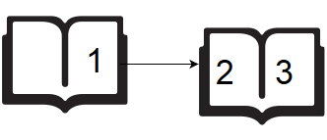

If Brie starts turning from page , she needs to turn  pages:

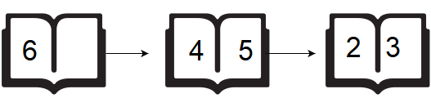

Because we want to print the minumum number of page turns, we print  as our answer.

**Sample Input 1**

5

4

**Sample Output 1**

0

**Explanation 1**

If Brie starts turning from page , she needs to turn  pages:

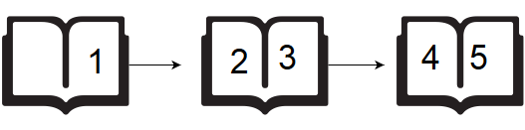

If Brie starts turning from page , she doesn't need to turn any pages:

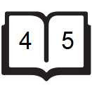

Because we want to print the minimum number of page turns, we print  as our answer.

*Solution:*

int main()

{

long pages, page;

cin>>pages >>page;

( page<=(pages/2) ? cout<<page/2 : cout<<(pages/2)-(page/2) );

return 0;

}

* Anshul Aggarwal